**Math 120  
5.1 System of Linear Equations**

# **Objectives:**

1. Determine whether an ordered pair is a solution of a linear system.
2. Solve linear systems by substitution.
3. Solve linear systems by addition.
4. Identify systems that do not have exactly 1 ordered pair solution.
5. Solve problems using systems of linear equations.

# **Topic #1 - System of Linear Equations in Two Variables/Two Equations**

A system of two linear equations can be thought of as two lines in the plane. The solution set is an ordered pair $(x,y)$ that satisfies both equations/falls on both lines.

From this geometric standpoint, three possibilities emerge:

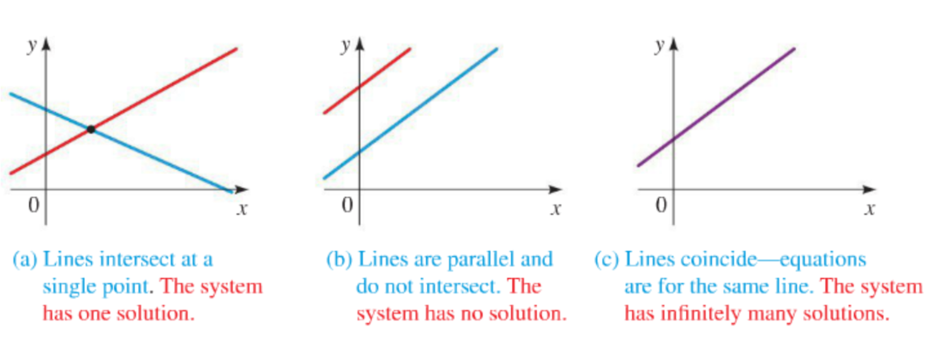

*Example #1* – Determine if the Ordered Pair is a Solution to the System

$\text{a. }\left\{\begin{aligned}y=4x-7 \\ 3x-4y=2\end{aligned}\right.$ Ordered Pair: $(2,1)$

This is a system, one line is in the form $y=mx+b$, the other in the form $Ax+By=C$. To determine if the given point works, plug into both systems where $x=2$ and $y=1$:

Both equations are true when plugging the values into the system. The ordered pair $(2,1)$**_________________** to the system.

$\text{b. }\left\{\begin{aligned}4x+3y=13 \\ 2x-4y=18\end{aligned}\right.$ Ordered Pair: $(4,-1)$

To determine if the given point works, plug into both systems where $x=4$ and $y=-1$.

The first equation is true, but the second one is false. The ordered pair $(4,-1)$**__________________________** to the system.

# **Topic #2 – Solving a System of Linear Equations: Substitution Method**

Consider the system from the previous example:

$$\left\{\begin{aligned}y=4x-7 \\ 3x-4y=2\end{aligned}\right.$$

Notice the first equation gives $y$ in terms of $x$, we can rewrite the second equation accordingly and solve for $x$:

Since $x=___________________$, we can go back to the first equation and solve for $y$.

Therefore, the solution to the system is ______________ We can check by plugging into both equations to confirm!

*Example #1* – Solve the System Using Substitution

$$\text{a. }\left\{\begin{aligned}2x+5y=0 \\ x-3y=0\end{aligned}\right.$$

Isolate $x$ in the second equation and it will be in terms of $y$:

Rewrite the first equation accordingly and solve for $y$:

Since $______________________$ we can go back to the second equation and solve for $x$:

Therefore, the solution to the system is _____________

Plug into the system to confirm.

$$\text{b. }\left\{\begin{aligned}x+3y=2 \\ 2x+5y=2\end{aligned}\right.$$

**Topic #3 – Solving a System of Linear Equations: Addition Method**

Consider the system:

$$\left\{\begin{aligned}y=4x-7 \\ 3x-4y=2\end{aligned}\right.$$

The first equation can be rewritten in $Ax+By=C$ form by subtracting $4x$:

There is a theorem that states an equation can be multiplied by any constant and that any two equations can be added together.

Suppose we multiply/scale all terms in the first equation by

$$\left\{\begin{aligned}-16x+4y=-28 \\ 3x-4y=2\end{aligned}\right.$$

 __________________

Notice the $y$ values are OPPOSITES, we can add the two equations together and the $y$ values drop out:

Therefore, the solution to the system is_____________ We can check by plugging into both equations to confirm!

*Example #1* – Solve the System Using Addition

$$\text{a. }\left\{\begin{aligned}2x+5y=0 \\ x-3y=0\end{aligned}\right.$$

Both equations are in $Ax+By=C$ form, so there is no need to rewrite either equation accordingly.

Multiply all terms in the second equation by ___________ to get OPPOSITE __________________

Therefore, the solution to the system is ______________

Plug into the system to confirm.

$$\text{b. }\left\{\begin{aligned}x+3y=2 \\ 2x+5y=2\end{aligned}\right.$$

Both equations are in $Ax+By=C$ form, so there is no need to rewrite either equation accordingly.

Multiply all terms in the second equation by ___________ to get OPPOSITE __________________

# **Topic #4 – Solving a System of Linear Equations: Graphing Method**

The solution to a system of two linear equations is where the two lines ___________________________________

Consider the system:

$$\left\{\begin{aligned}y=4x-7 \\ 3x-4y=2\end{aligned}\right.$$

If using a graphing calculator, both equations must be solved for $y$:

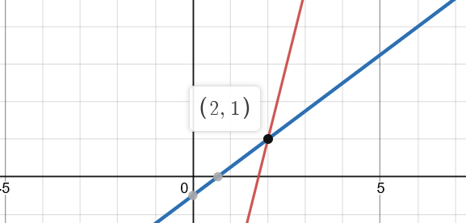

$$\left\{\begin{aligned}y=4x-7 \\ 3x-4y=2\end{aligned}\right.→\left\{\begin{aligned}y=4x-7 \\ y=\frac{\left(2-3x\right)}{-4}\end{aligned}\right.$$

Here is the graph:

The solution to the system is where the lines meet, at the point $(2,1)$.

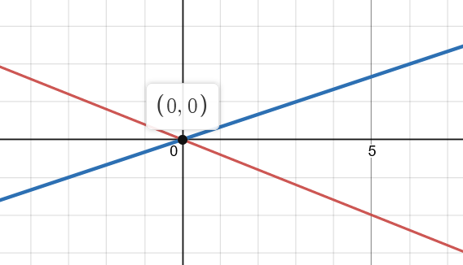*Example #1* – Solve the System Using Graphing

$$\text{a. }\left\{\begin{aligned}2x+5y=0 \\ x-3y=0\end{aligned}\right.$$

Solve both equations for $y$ if using a graphing calculator:

$$\left\{\begin{aligned}2x+5y=0 \\ x-3y=0\end{aligned}\right.→$$

Here is the graph:

The solution to the system is where the lines meet, at the point ____________________

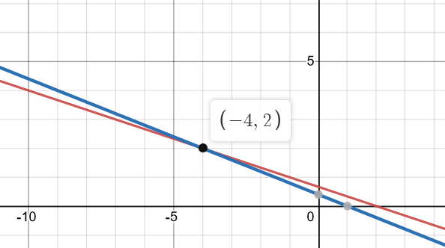

$$\text{b. }\left\{\begin{aligned}x+3y=2 \\ 2x+5y=2\end{aligned}\right.$$

Solve both equations for $y$ if using a graphing calculator:

$$\left\{\begin{aligned}x+3y=2 \\ 2x+5y=2\end{aligned}\right.→$$

Here is the graph:

The solution to the system is where the lines meet, at the point __________________________

# **Topic #5 – System of Linear Equations with No Solution**

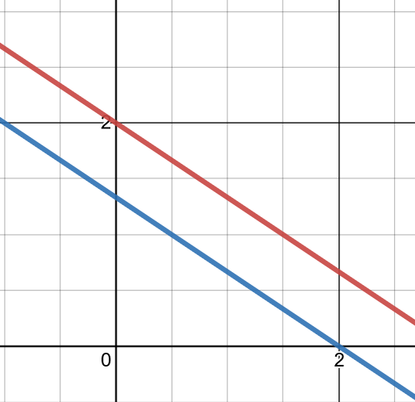A system with **no solution** is two lines in the plane that DO NOT meet ___________________. A graph will show this and solving with addition or substitution will produce a ____________________statement when both variables drop out.

Consider the system:

$$\left\{\begin{aligned}2x+3y=6 \\ 6x+9y=12\end{aligned}\right.$$

By the addition method, multiply the terms of first equation by $-3$:

Adding the equations results in both variables dropping out and _______________________

A graph confirms the lines are __________________ which also indicates NO SOLUTION:

$$\left\{\begin{aligned}2x+3y=6 \\ 6x+9y=12\end{aligned}\right.→$$

Feel free to try out the substitution method; it also will cause both variables to drop out and leave a FALSE statement.

**Topic #6 – System of Linear Equations with Infinitely Many Solutions**

A system with **infinitely many solutions** are two lines that coincide __________________________________

A graph will show this and solving with addition or substitution will produce a ____________________ when both variables drop out.

Consider the system: $\left\{\begin{aligned}y=3x-2 \\ 15x-5y=10\end{aligned}\right.$

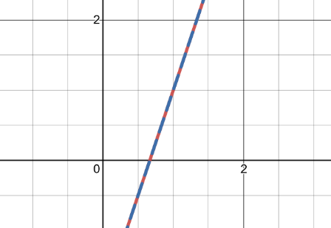By the substitution method, the first equation has $y$ in terms of $x$. Rewrite the second equation accordingly to solve for $x$:

The variables drop out and the statement is TRUE, which indicates ________________________________

A graph confirms the lines are the SAME, which also indicates INFINITELY MANY SOLUTIONS: $\left\{\begin{aligned}y=3x-2 \\ 15x-5y=10\end{aligned}\right.→$

Feel free to try out the addition method; it also will cause both variables to drop out and leave a TRUE statement.

**Topic #7 – Application of Systems of Linear Equations: Revenue, Cost, and Profit Functions**

Suppose a company produces and sells $x$ units of a product. The revenue is the money generated by selling $x$ units and the cost is the amount spent producing $x$ units.

Revenue Function: $R\left(x\right)=\left(\text{price per unit sold}\right)x$

Cost Function: $C\left(x\right)=\text{fixed cost}+\left(\text{cost per unit produced}\right)x$

The profit is what is left over from the revenue after the cost is taken out:

Profit Function: $P\left(x\right)=R\left(x\right)-C(x)$

The break-even point is where

$P\left(x\right)=0$ OR where $R\left(x\right)=C(x)$

*Example #1* – Build and Solve a System of Linear Equations

A company manufactures and sells a certain model of Bluetooth speakers. The fixed cost to operate daily production is $\$18,000$ and it costs $\$20$ to produce each speaker. The selling price is $\$80$ per speaker. Assume each unit produced is sold.

a. Write the cost function.

Let x be:

Let C(x) be:

b. Write the revenue function.

Let x be:

Let R(x) be:

c. Determine the break-even point and interpret the meaning in context.

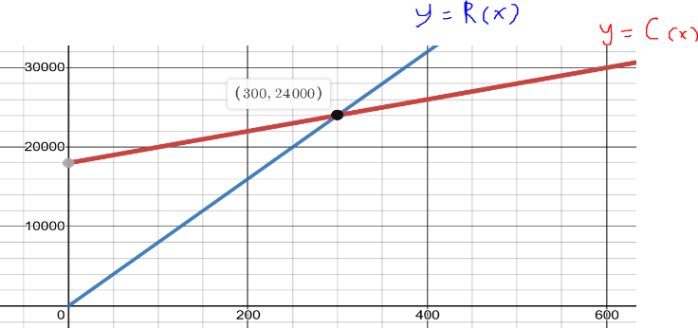

This means that the company will break-even (neither make nor lose money) by producing and selling ________________speakers. A graph confirms:

d. Will the company make a profit by producing and selling $250$ units? Explain.

Using the definition: $P\left(x\right)=R\left(x\right)-C\left(x\right)$

When $x=250$

____________________________

This means the company will _________________________ by producing and selling 250 units; ____________________________________